Name: Kevin Yang-Li
Date: 09/27/2021
10.08 Elevens Lab Worksheet
Directions: Make note of your responses to the following questions as you work through the activities and exercise in the lesson.

Activity 1 Exercise Results
- From step a, paste your Card class constructor below.
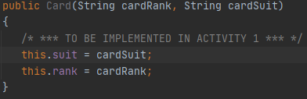
From step c, paste your matches method below.
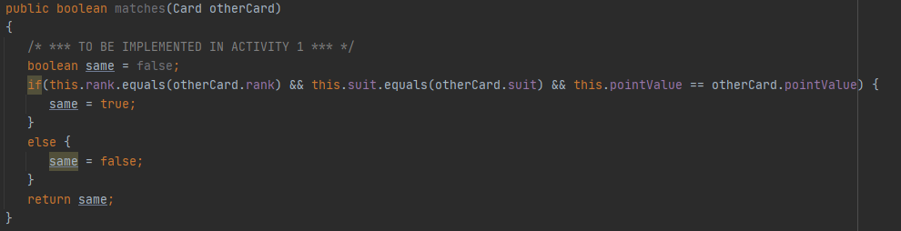
- Paste the results of running the CardTester.java class below.
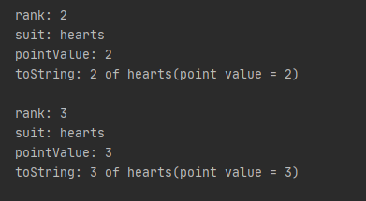
Activity 2 Exercise Results
- From step a, paste your Deck class constructor below.
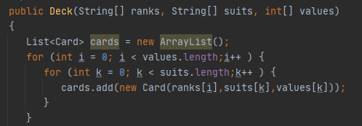
From step b, paste your isEmpty method below.
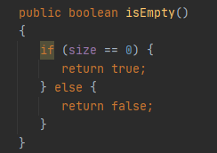
From step d, paste your deal method below.
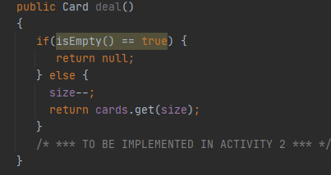
Paste the results of running the DeckTester.java class below.
**** Original Deck Methods ****
- toString:
- size = 52
- Undealt cards:
- king of clubs(point value = 13), king of diamonds(point value = 13),
- king of spades(point value = 13), king of heart(point value = 13),
- queen of clubs(point value = 12), queen of diamonds(point value = 12),
- queen of spades(point value = 12), queen of heart(point value = 12),
- Jack of clubs(point value = 11), Jack of diamonds(point value = 11),
- Jack of spades(point value = 11), Jack of heart(point value = 11),
- ten of clubs(point value = 10), ten of diamonds(point value = 10),
- ten of spades(point value = 10), ten of heart(point value = 10),
- nine of clubs(point value = 9), nine of diamonds(point value = 9),
- nine of spades(point value = 9), nine of heart(point value = 9),
- eight of clubs(point value = 8), eight of diamonds(point value = 8),
- eight of spades(point value = 8), eight of heart(point value = 8),
- seven of clubs(point value = 7), seven of diamonds(point value = 7),
- seven of spades(point value = 7), seven of heart(point value = 7),
- six of clubs(point value = 6), six of diamonds(point value = 6),
- six of spades(point value = 6), six of heart(point value = 6),
- five of clubs(point value = 5), five of diamonds(point value = 5),
- five of spades(point value = 5), five of heart(point value = 5),
- four of clubs(point value = 4), four of diamonds(point value = 4),
- four of spades(point value = 4), four of heart(point value = 4),
- three of clubs(point value = 3), three of diamonds(point value = 3),
- three of spades(point value = 3), three of heart(point value = 3),
- two of clubs(point value = 2), two of diamonds(point value = 2),
- two of spades(point value = 2), two of heart(point value = 2),
- Ace of clubs(point value = 1), Ace of diamonds(point value = 1),
- Ace of spades(point value = 1), Ace of heart(point value = 1)

- Dealt cards:

- isEmpty: false
- size: 52

- **** Deal a Card ****
- deal: king of clubs(point value = 13)

- **** Deck Methods After 1 Card Dealt ****
- toString:

- isEmpty:
- size:

- **** Deal Remaining 5 Cards ****

- **** Deck Methods After All Cards Dealt ****
- toString:

- isEmpty:
- size:

- **** Deal a Card From Empty Deck ****
- deal:

Activity 2 Questions:

- Explain in your own words the relationship between a deck and a card.
In the case of this program, I created a constructor to create a card object. Then, I created a deck object, an object that has the property of holding card objects. Therefore, a deck is just a group of cards together. An object made of smaller objects.

- Consider the deck initialized with the statements below. How many cards does the deck contain? __6__

String[] ranks = {"jack", "queen", "king"};
String[] suits = {"blue", "red"}; int[] pointValues = {11, 12, 13};
Deck d = new Deck(ranks, suits, pointValues);
- Many card games are played with a deck of 52 cards. It is common for ranks to run from ace (highest) down to 2 (lowest). Suits are spades, hearts, diamonds, and clubs. A face card has point value 10; an ace has point value 11; point values for 2, …, 10 are 2, …, 10, respectively. Write the statements to declare and initialize the contents of the ranks, suits, and pointValues arrays so that the following statement initializes a deck as described.
String[] ranks = { "two", "three", "four", "five", "six", "seven", "eight", "nine", "ten", ”Ace" };
String[]suits = {"heart", "spades", "diamonds", "clubs"};
int[]pointValues = {2,3,4,5,6,7,8,9,10,11 };

Deck d = new Deck(ranks, suits, pointValues);
- Does the order of elements of the ranks, suits, and pointValues arrays matter?
  - Yes, the order does matter since in my code I’m using a for-loop with an index to assign the values to every card. Specifically since I’m using the same index to assign the rank and pointValue of a card. The order of the rank array must match the order of the pointValue array. However, I do not think that the order of the suits matters since no matter what every rank will have the 4 suits.

